A picture containing clipart

Description generated with very high confidence

Azure 103 Module 4

Hands On - 3

Azure Certification Training

[**support@intellipaat.com**](mailto:support@intellipaat.com)

**+91-7022374614**

**US: 1-800-216-8930(Toll Free)**

**Azure 103 Module 2 , Hands On – 3**

**Create and Configure Azure Blob Storage**

**Step 1:** Open Storage Account.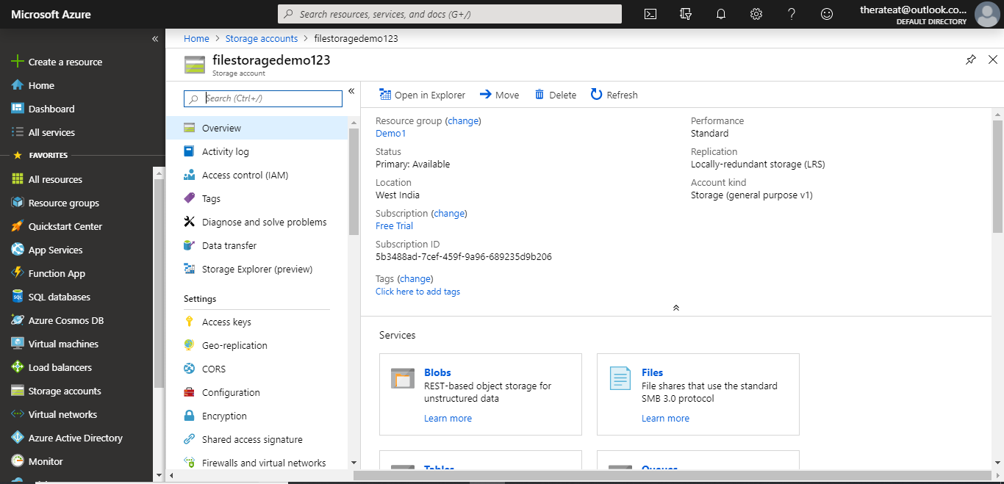

**Step 2:** Click on BLOBS.

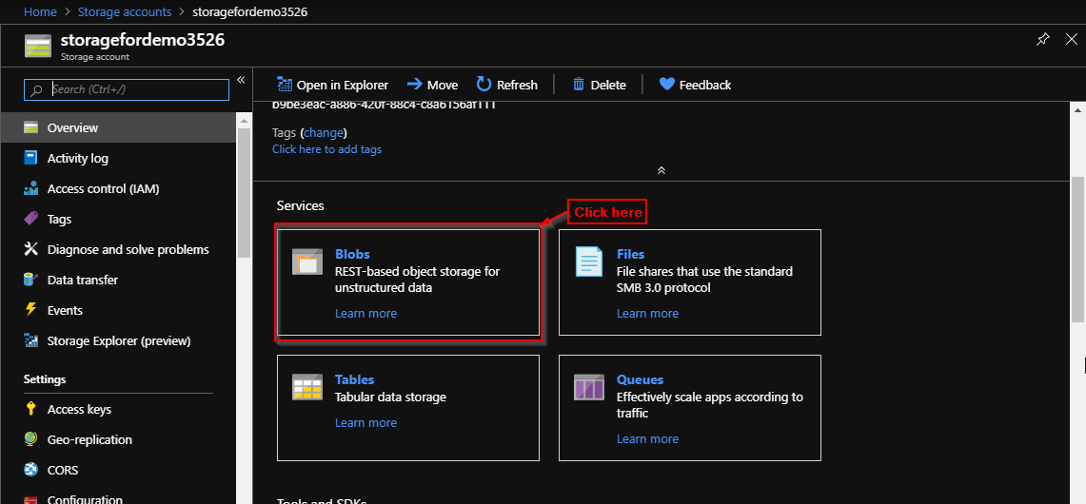

**Step 3:** Click on + Container.

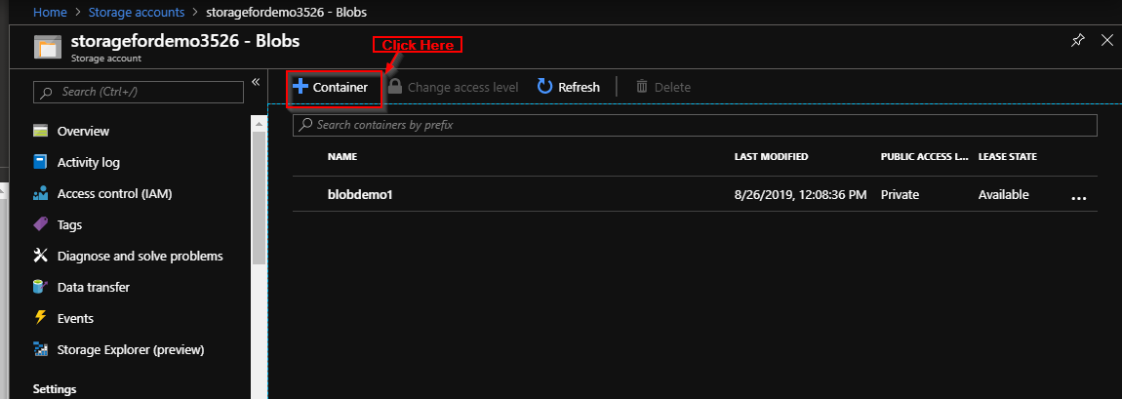

**Step 4:** Enter name and select access level and click ok.

